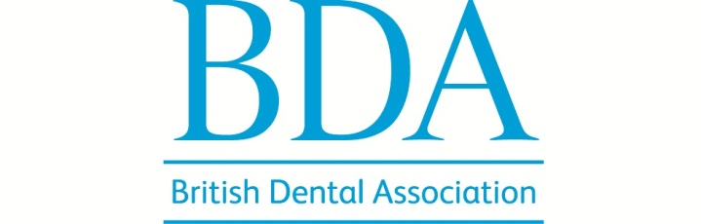

BDA Dental Museum volunteering expression of interest form

Name
Address

Email
Please confirm you are over 18 ◻
Telephone | Day | Evening | Mobile
Do you have any access requirements? (e.g. Large print, hearing loop, wheelchair access)

Your availability (please tick as appropriate)
Mon am pm Tue am pm Wed am pm Thu am pm Fri am pm
◻ ◻ ◻ ◻ ◻ ◻ ◻ ◻ ◻ ◻ Varies ◻
Please tell us a little about yourself including any experience, skills or particular interests you have. Please continue overleaf.

Please give a referee whom we may contact
Name
Address

Tel no./Email
How do you know the referee?

I understand that any offer of volunteering with the BDA Dental Museum is subject to a satisfactory reference, and is binding in honour only.
Signature
Date
For museum staff
Reference checked? I.D. checked?
We will keep your information secure in line with the Data Protection Act and only use it for the purposes of any volunteering you undertake.

