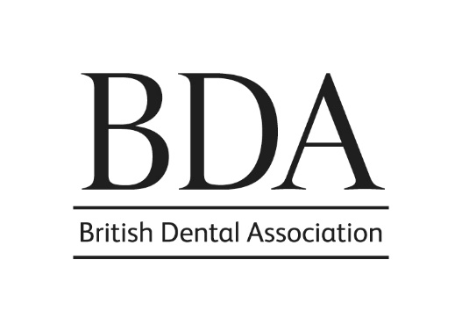

**NOMINATION FORM FOR BDA HONOURS & AWARDS**

**This advice has been put together to help you complete a nomination submission with sufficient details to allow the Honours and Awards Committee to make an informed decision. The suggestions are not exhaustive.**

**It is important to try and complete as many sections as possible. Not all successful nominations require every section to be completed. However, the more sections you are able to complete, the more likely the award is to be successful.**

**Self-nomination is not allowed. We are aware that to be able to complete this nomination form, you may need to ask the nominee for a copy of their cv, and this is acceptable. Only one nomination form can be considered for an individual.**

|  |  |  |
| --- | --- | --- |
| Nominating Branch /Section / Group/ Committee or professional association (as appropriate) | Other than in exceptional circumstances, the nomination should have the support of a nominating Branch/Section/Group, BDA Committee or professional association | |
| Name of contact person and office held |  | |
| Contact details for correspondence  (Address, telephone number and email of contact person) | For all nominations, this will be the point of contact for giving information on the process and outcome of the nomination | |
| **Personal Details of Nominee** | | |
| Name of Nominee | | Please complete the full name of the nominee, ensuring it is the name that is used for the Dental Register and BDA membership. |
| Membership Address | | It is important to give accurate core details, as we use this information to check against our records to assess qualification for award category. |
| Qualifications with relevant dates | |  |

|  |  |
| --- | --- |
| BDA Membership – including the date membership commenced | Please read the information on the categories carefully to ensure your nominee qualifies for the award you are nominating them for. Life Membership is normally awarded at or after retirement. |
| Honour or Award for which they are being nominated | Please refer to the information on categories at the end of the form. |

|  |
| --- |
| **Career Information**  Please detail nominee’s sphere(s) of practice, with dates, places and appointments held, and date of retirement (if applicable). |
| For this section, it will be helpful to you to have sight of the nominee’s cv.  If you are not sure of detailed dates, please don’t include them. |

|  |
| --- |
| **BDA Activity** |
| (i) Please provide details of activity at Branch and Section and/or Group level, including membership of Branch Council, Group Committees, etc, with dates. Please include details of any outstanding service to Branch, Section and Group or members locally.  For nominees who are not dentists, it is important to include in this section the nominee’s contribution to the work of the BDA and UK dentistry. |
| (ii) Please provide details of membership of national BDA Committees, Sub-Committees and Working Parties, with dates, offices held, etc. |
| (iii) Please provide details of any representation of the Association on outside bodies at national level. |
| (iv) Please provide details of any other special contributions. |

|  |
| --- |
| **Other Committee Experience**  Please provide details of any involvement with other associated Committees. |

|  |
| --- |
| **International Activity**  Please provide details of any involvement at international level (eg. FDI). |
|  |

|  |
| --- |
| **Specialist Societies**  Please provide details of memberships with any specialist societies, with offices and dates. |
| Please give all details of contributions to Specialist Societies |

|  |
| --- |
| **Scientific achievements**  Please list publication in peer-reviewed journals and any published books and contributions to books as well as any significant successful grant applications and research |
| It is important this section is comprehensively completed for nominations for the John Tomes medal.  Please give brief overall view of research activity and its impact.  Publications and successful grant applications should be listed here. |

|  |
| --- |
| **Other contributions to professional activity**  Please provide details of any other contributions to the profession (eg speaker at Branch and Section meetings, postgraduate courses etc) |
| Please give brief details of speaking contributions. (For some nominations, speaking engagements will be too excessive to list individually)  Involvement in LDCs  Evidence of leadership in postgraduate training  Evidence of leadership in Public and Oral Health initiatives  Evidence of leadership in regulation  Evidence of leadership in the NHS  Evidence of leadership in indemnity organisations |

|  |
| --- |
| **Has your nominee contributed to exemplary patient care?**  Please provide examples or details |
| Developing new clinical pathways which have had proven clinical benefit  Involvement in area, regional or national quality improvement initiatives  Leadership within MCNs etc  **Examples of individual patient care should *not* be included here** |

|  |
| --- |
| **Has your nominee contributed above and beyond what is expected in the response to the SARS-CoV-2 pandemic?**  Please give details |
| This section will remain for the period of the COVID-19 pandemic.  It is important to note that details included on this section ***must be over and above*** what would be expected as the role and responsibility of the nominee’s employment and/or contractual responsibilities. |

|  |
| --- |
| **Statement of Support**  Please summarise the reasons why the Branch/Section/Group, BDA Committee or professional association is nominating this individual for a BDA Honour or Award *(approx 200 words - please continue on a separate sheet if necessary).* |
|  |